3.4: 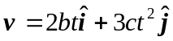. This vector will make a 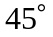-angle with both axes when the x- and y-components are equal; in terms of the parameters, this time is 

